ACTIVITY 1

CANE TOADS

# DIRECTIONS

Have one group member upload this docx file to your Google Drive and share it with your groupmates and your instructor. Name your document “**GroupX_Activity1”** (where X is your group number). Work together to type up your responses to each question. Download your document as a PDF and submit this to Canvas individually.

# CREDITS

This activity has been adapted from original tasks developed by Dr. Laura Taylor, Associate Professor of Statistics, Elon University. Additional thanks to Roger Woodward at Notre Dame University for the creation of the 3D printed scooping paddles.

# PART 1: CANE TOADS

You are all ready to participate in your first day as an ecologist studying an invasive species of cane toads. Your goal is to determine the percentage of cane toads in a particular forest that are female. Unfortunately, due to time and budget constraints you are only able to capture and study 50 of the toads.

The container that your instructor has represents the forest we are interested in studying. Each red bead represents a female cane toad in the forest, and each white bead represents a male cane toad in the forest.

## INITIAL QUESTIONS

1. Based on looking at the container at the start of class, what *percentage* of the cane toads do you think are female? (i.e. What percentage of the beads do you think are red?)
2. If you randomly select 50 cane toads and calculate the *percentage* that are female, which statement best reflects your view? Explain why.
   1. The percentage calculated will be the same as the percentage of female cane toads in the whole forest
   2. The percentage calculated will be “close to” the percentage of female cane toads in the whole forest
   3. The percentage calculated will not give any real information about the percentage of female cane toads in the forest since the forest contains many more than 50 cane toads.
3. If each person in class randomly selects 50 cane toads, which statement best reflects your view? Explain why.
4. Each person should get the same percentage of female cane toads in the 50 they select
5. Each person should get “close to” the same percentage of female cane toads in the 50 they select.
6. Each person will get very different percentages of female cane toads among the 50 they select.

## GATHERING YOUR SAMPLE

Have one of your group members take a sample of 50 cane toads from the container and count the number of red beads. This is the number of female cane toads in your sample.

**Important:** Do not take the beads with you! Take a scoop, count them in the scoop, and then dump them back in the container.

1. Number of female cane toads in your sample = ______________
2. Percentage of female cane toads in your sample = ______________

After you’ve taken your sample, have each group member add the **percentage** of female cane toads you got to the TinkerPlots table on the instructor computer. As values are added, TinkerPlots will build a graph of dots for each of these values. This is what statisticians call a **sampling distribution,** or the distribution that is created as a result of repeated sampling. This shows some of the different percentages we might get if we took a bunch of samples of 50 cane toads from this forest.

Once this sampling distribution has been built up from all the different observations from groups, answer the questions on the next page.

## FOLLOW-UP QUESTIONS

1. Based on the graph of sample percentages from you and your classmates, what percentage of the cane toads in the whole forest do you think are female?
2. Based on the samples from our class, do you think it's plausible that 40% of the cane toads in the whole forest are female? Why or why not? (**choose one of the following answers below)** 
   1. Yes. 40% is near the center of the graph, so 40% is a reasonable guess for the percentage of female cane toads in the forest.
   2. Yes. We don't know the true percentage of female cane toads in the forest, so any percentage is plausible.
   3. No. 40% wasn't the most common percentage in our class samples, so the true percentage in the forest should be something else.
   4. No. Very few people got samples with around 40% female cane toads, so it is unlikely that the true percentage in the forest is 40%.
3. Based on the samples from our class, do you think it's plausible that 70% of the cane toads in the whole forest are female? Why or why not? (**choose one of the following answers below)**
4. Yes. 70% is near the center of the graph, so 70% is a reasonable guess for the percentage of female cane toads in the forest.
5. Yes. We don't know the true percentage of female cane toads in the forest, so any percentage is plausible.
6. No. 70% wasn't the most common percentage in our class samples, so the true percentage in the forest should be something else.
7. No. Very few people got samples with around 70% female cane toads, so it is unlikely that the true percentage in the forest is 70%.

## SAMPLING CANE TOADS USING SIMULATION

For the next few questions, we will use TinkerPlots to generate a graph of 100 different samples from this forest. This would take far too long to do with the beads, but with a computer, we can do it in an instant. Open the CaneToads.tp3 file from Canvas. **Note: TinkerPlots files do not open by clicking on the file directly. Open TinkerPlots first, then go to File -> Open, and navigate to the .tp3 file.** The file contains a mystery sampler that has the same percentage of female toads inside it as the bin in the classroom.

### running a sample

Click run to generate a random selection of 50 cane toads. Once this is done, click and drag the plot button to make a plot appear on the screen. You can click on the “N” button or the “%” button at the top to enable counts or percents on your plot.

1. What percentage of the cane toads in your simulation were female? Paste an image of your plot below that answers this question.

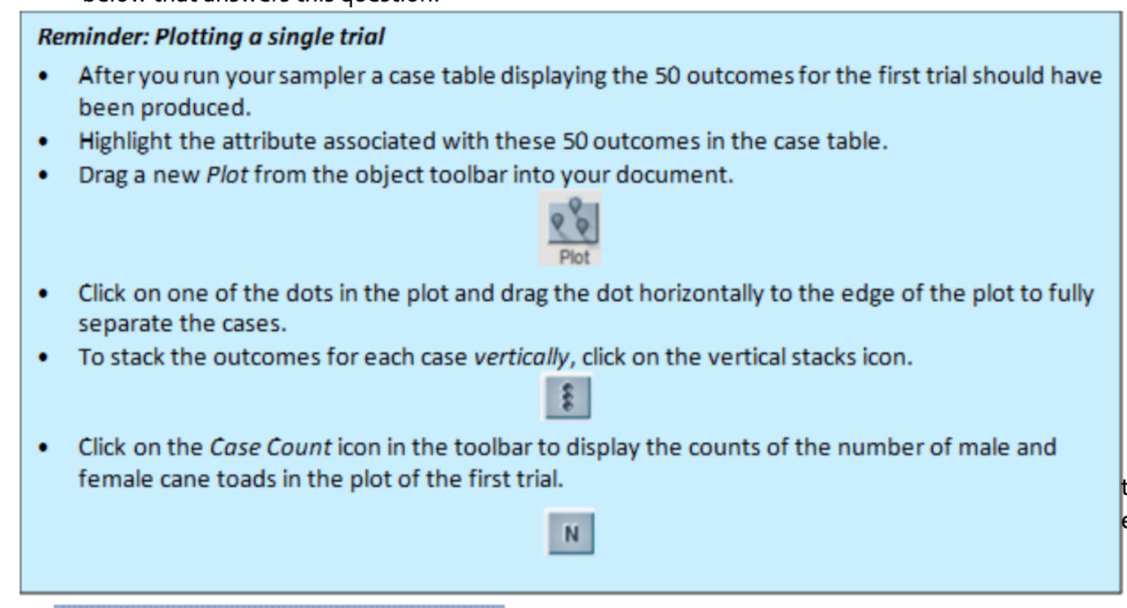

### CREATING A SAMPLING DISTRIBUTION

When we sampled cane toads as a class, we compiled all of our results together to show a **sampling distribution** of percentages. To simulate this in TinkerPlots much faster than we did as a class, we can use the collect statistics feature. To use this, right click on the number that you would like to track, in this case, the percentage of female cane toads, and then click “Collect Statistic.”Graphical user interface, qr code

This creates a history table in TinkerPlots, as shown below. This keeps track of what happens with the number you collected statistics on each time you click “Run,” similar to how we collected values as a class earlier. Rather than clicking run repetitively, we can simply type the number of trials we want to run in the box at the top of the table, and then click “Collect.” Let’s do 99 additional trials for a total of 100 – type 99 in the box as shown below and click “Collect.”

Once we do this, we can create a plot of these percentages by clicking and dragging on a plot from the top bar. Drag a dot to the right to organize the results.

1. Paste an image of the resulting sampling distribution plot from TinkerPlots. How would you describe the “shape” of the sampling distribution of the percentage of female cane toads in the forest? (Think about your pre-work assignment you turned in before this class!)
2. Based on this larger simulation, what percentage of cane toads in the forest do you think are female? Why did you select this value?

1. In general, what percentages were most typical in our random samples from the container and in our simulation?

## EXTENSIONS

1. If I had collected 500 statistics instead of 100 statistics, how do you think the sampling distribution would change?
2. If I had a scoop that could take a sample of 100 toads at a time, how do you think the sampling distribution in question 10 would change?